**Surface Integrals**

copyright © 2009 by Jonathan Rosenberg based on an earlier M-book, copyright © 2000 by Paul Green and Jonathan Rosenberg

**Contents**

* [Surface Area and Surface Integrals](file:///M:\HTML%20files\surfint.html#1)
* [Example 1](file:///M:\HTML%20files\surfint.html#2)
* [Example 2](file:///M:\HTML%20files\surfint.html#8)
* [Problem 1](file:///M:\HTML%20files\surfint.html#12)
* [Flux Integrals](file:///M:\HTML%20files\surfint.html#13)
* [Example 3](file:///M:\HTML%20files\surfint.html#14)
* [Problem 2](file:///M:\HTML%20files\surfint.html#17)
* [The Divergence Theorem](file:///M:\HTML%20files\surfint.html#18)
* [Example 4](file:///M:\HTML%20files\surfint.html#19)
* [Problem 3](file:///M:\HTML%20files\surfint.html#24)
* [Additional Problems](file:///M:\HTML%20files\surfint.html#25)

**Surface Area and Surface Integrals**

In this lesson, we will study integrals over parametrized surfaces. Recall that a surface is an object in 3-dimensional space that locally looks like a plane. In other words, the surface is given by a vector-valued function **P** (encoding the x, y, and z coordinates of points on the surface) depending on two parameters, say u and v. The key idea behind all the computations is summarized in the formula

$$ \frac{\partial\overrightarrow P}{\partial u} \times \frac{\partial\overrightarrow P}{\partial v} \,du\,dv = \overrightarrow n\, dS. $$

Since **P** is vector-valued,

$$\frac{\partial\overrightarrow P}{\partial u}, \quad \frac{\partial\overrightarrow P}{\partial v}$$

are vectors, and their cross-product is a vector with two important properties: it is normal to the surface parametrized by P, and its length gives the scale factor between area in the parameter space and the corresponding area on the surface. Thus, taking lengths on both sides of the above formula above gives

$$ \left\Vert\frac{\partial\overrightarrow P}{\partial u} \times \frac{\partial\overrightarrow P}{\partial v} \right\Vert \,du\,dv = dS,$$

which enables us to compute the area of a parametrized surface, or to integrate any function along the surface with respect to surface area.

**Example 1**

To see how this works, let us compute the surface area of the ellipsoid whose equation is

$$ \frac{x^2}{4} + \frac{y^2}{9} + z^2 = 1. $$

We may parametrize this ellipsoid as we have done in the past, using modified spherical coordinates:

syms x y z p t

ellipsoid=[2\*sin(p)\*cos(t),3\*sin(p)\*sin(t),cos(p)]

ellipsoid =

[ 2\*cos(t)\*sin(p), 3\*sin(p)\*sin(t), cos(p)]

To check that this really is a parametrization, we verify the original equation:

simplify(subs((x^2/4)+(y^2/9)+z^2,[x,y,z],ellipsoid))

ans =

1

And we can also draw a picture with **ezsurf**:

ezsurf(ellipsoid(1),ellipsoid(2),ellipsoid(3),[0,pi,0,2\*pi])

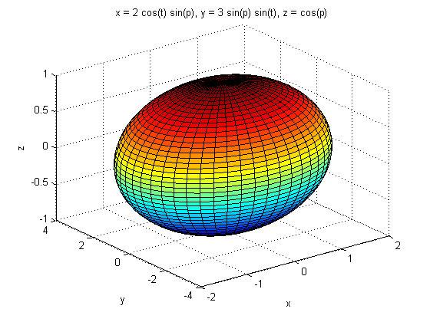

This is as it should be. Now we compute the surface area factor:

realdot = @(u,v) u\*transpose(v);

veclength = @(u) sqrt(realdot(u,u));

surffactor = simple(veclength(cross(diff(ellipsoid,t), ...

diff(ellipsoid,p))))

surffactor =

(36\*sin(p)^2 - 27\*sin(p)^4 - 5\*sin(p)^4\*sin(t)^2)^(1/2)

This is going to be too complicated to integrate symbolically, so we do a numerical integration, using the numerical integration toolbox at [http://www.math.umd.edu/~jmr/241/mfiles/nit/](http://www2.math.umd.edu/%7Ejmr/241/mfiles/nit/).

addpath nit

area=newnumint2(surffactor,p,0,pi,t,0,2\*pi)

area =

48.8822

To integrate a function, such as

$$x^2 + 2z^2, $$

over the surface, we must express it in terms of the parameters and insert the result as a factor in the integrand.

func=subs(x^2+2\*z^2,[x,y,z],ellipsoid)

integral=newnumint2(surffactor\*func,p,0,pi,t,0,2\*pi)

func =

2\*cos(p)^2 + 4\*cos(t)^2\*sin(p)^2

integral =

100.5002

**Example 2**

Here's another example: suppose we want the surface area of the portion of the cone z^2 = x^2 + y^2 between z = 0 and z = 4. The equation of the cone in cylindrical coordinates is just z = r, so we can take as our parameters r and t (representing theta).

syms r; cone=[r\*cos(t),r\*sin(t),r]

cone =

[ r\*cos(t), r\*sin(t), r]

The picture is:

ezsurf(cone(1),cone(2),cone(3),[0,4,0,2\*pi])

conesurffactor=simple(veclength(cross(diff(cone,r),diff(cone,t)) ))

conesurffactor =

(2\*r^2)^(1/2)

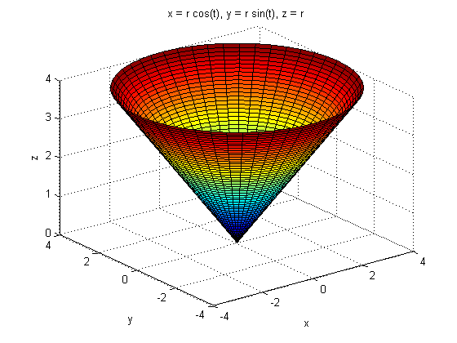

Since r is positive, we can ignore the sign csgn(r), and the surface area is

conesurf=symint2(2^(1/2)\*r,r,0,4,t,0,2\*pi)

conesurf =

16\*pi\*2^(1/2)

This is right since we can also "unwrap" the cone to a sector of a circular disk, with radius 4\*sqrt(2) and outer circumference 8\*pi (compared to 8\*pi\*sqrt(2) for the whole circle), so the surface area is

$$ \pi \left(4 \sqrt{2}\right)^2 / \sqrt{2} = 16\pi\sqrt{2}. $$

**Problem 1**

(a) Compute the surface area of the portion of the paraboloid z = 9 - x^2 - y^2 that lies above the xy-plane.

(b) Evaluate

$$ \int\!\int_\Sigma z^{3/2}\,dS, $$

where Sigma is the surface whose area you found in part (a).

**Flux Integrals**

The formula

$$ \frac{\partial\overrightarrow P}{\partial u} \times \frac{\partial\overrightarrow P}{\partial v} \,du\,dv = \overrightarrow n\, dS $$

also allows us to compute flux integrals over parametrized surfaces.

**Example 3**

Let us compute

$$\int\!\int_E \overrightarrow F \cdot \overrightarrow n\,dS,$$

where the integral is taken over the ellipsoid E of Example 1, **F** is the vector field defined by the following input line, and **n** is the outward normal to the ellipsoid.

F = [x,y,z]

ndS = cross(diff(ellipsoid,p),diff(ellipsoid,t))

F =

[ x, y, z]

ndS =

[ 3\*cos(t)\*sin(p)^2, 2\*sin(p)^2\*sin(t), 6\*cos(p)\*sin(p)\*cos(t)^2 + 6\*cos(p)\*sin(p)\*sin(t)^2]

We can check that we have the outward normal by setting p=pi/2 and t=0, giving us the point of the ellipsoid that is on the positive x-axis. The outward normal should point in the positive x direction.

subs(ndS,[p,t],[pi/2,0])

ans =

3.0000 0 0.0000

Before we can evaluate the integral, we must evaluate **F** in terms of the parameters.

Fpar = subs(F,[x,y,z],ellipsoid)

flux = symint2(realdot(Fpar,ndS),p,0,pi,t,0,2\*pi)

Fpar =

[ 2\*cos(t)\*sin(p), 3\*sin(p)\*sin(t), cos(p)]

flux =

24\*pi

**Problem 2**

Evaluate

$$\int\!\int_\Sigma \overrightarrow G \cdot \overrightarrow n\,dS, $$

where Sigma is the surface of Problem 1 and **G** is defined by the input line below.

G=[2\*x,y,z-2]

G =

[ 2\*x, y, z - 2]

**The Divergence Theorem**

**Example 4**

The Divergence Theorem predicts that we can also evaluate the integral in Example 3 by integrating the divergence of the vector field **F** over the solid region bounded by the ellipsoid. But one caution: the Divergence Theorem only applies to **closed** surfaces. That's OK here since the ellipsoid is such a surface. To facilitate the calculation we have written a short M-file <http://www.math.umd.edu/users/jmr/241/mfiles/div.m>. Although the computation of the divergence is trivial in the present case, we illustrate the syntax:

divF = div(F,[x,y,z])

divF =

3

We must now parametrize the solid ellipsoid. We can do this most easily by adding a radial factor r that takes values between 0 and 1. Note that since ellipsoid is a vector, all we have to do is "scalar multiply" it by r:

syms r

solid = r\*ellipsoid

solid =

[ 2\*r\*cos(t)\*sin(p), 3\*r\*sin(p)\*sin(t), r\*cos(p)]

Recall that to integrate in the coordinates r, p, and t, we are going to have to insert a scale factor, the absolute value of the determinant of the Jacobian matrix of the change of variables. As we indicated is last week's lesson, it's usually easiest to leave off the absolute value at first, and then change the sign if the scale factor comes out negative.

scale=simple(det(jacobian(solid,[r,p,t])))

scale =

6\*r^2\*sin(p)

That's clearly positive, and it's simple enough to make a symbolic integration feasible.

answer = int(symint2(3\*scale,r,0,1,p,0,pi),t,0,2\*pi)

answer =

24\*pi

This agrees with our calculation of the flux. The numerical value is:

double(24\*pi)

ans =

75.3982

**Problem 3**

With **G** and Sigma as in Problems 1 and 2, integrate the divergence of **G** over the solid region bounded above by Sigma and below by the xy-plane. Why is your answer not the same as the answer to Problem 2?

**Additional Problems**

1. Check the accuracy of the computation in Example 1 above by repeating the integration over the ellipsoid, using x and y as the parameters and solving for z as a function of x and y. (Hint: since there are two solutions for z, but the surface is symmetric, just integrate over the top half of the ellipsoid and then double the result.)

2. Let

$$ f(x,y,z) = 2x^2 + 3y^2 +6z^2  . $$

Compute the flux of the gradient of f through the ellipsoid

$$ x^2 + 4y^2 + 9z^2 = 36, $$

both directly and by using the Divergence Theorem.

3. Let T be the torus with equation z^2 + (r-2)^2 = 1 in cylindrical coordinates. Parametrize the torus and use the answer to compute the surface area.

4. Let T be the same torus as in Additional Problem 3 just above. Compute the volume enclosed by the torus two ways: by triple integration, and by computing the flux of the vector field **F** = (x, y, z) through T and by using the Divergence Theorem. Check that the results agree, and also that they agree with the prediction of Pappus's Theorem (see Ellis and Gulick): the volume of a solid obtained by rotating a region R in the xz-plane around the z-axis is the area of R times the circumference of the circle traced out by the center of mass of R as it rotates around the z-axis.

Published with MATLAB® 7.8